Stacking model or Stacking Classifier is one of the important technique used and it is much more similar to ensemble.

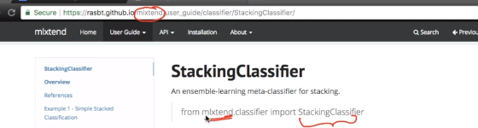

mlxtend works very close to sklearn and is very popular library for building Stacking Classifiers.

So the concept of Stacking model is like we train multiple models parallely and those are independent of each other.

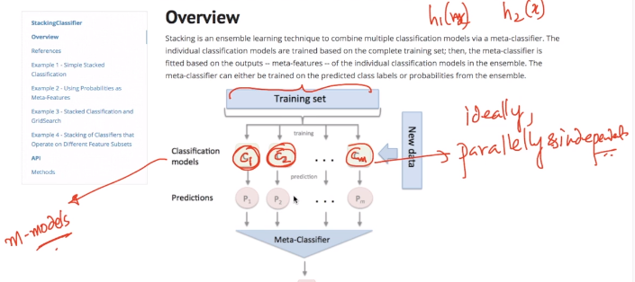

More different this models are the better stacking works in practical but theoretically it can be anything.

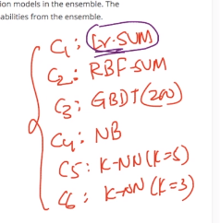

The basic difference between RF and stacking is that in RF all the classifiers were high variance - low bias model but in stacking all the classifiers are well tuned models .

And in RF we just used to take majority vote for any Yi but in Stacking we are using another meta classifier that itself can be any model i.e. LR , Decision Tree or any other on all Yi’s.

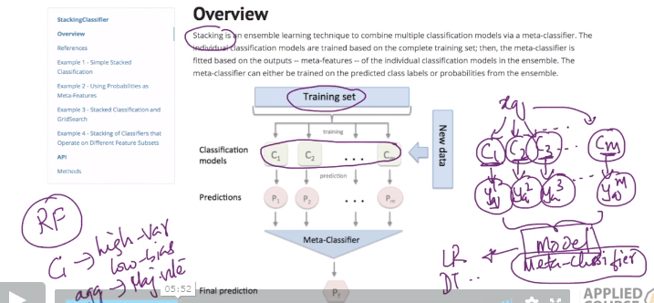

And the final output for any Xi will come from Meta-Classifier.

Lets see this in algorithmic fashion.

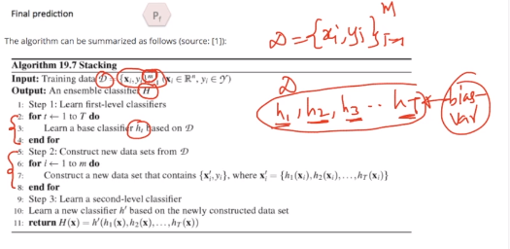

So here in first step we will have T classifiers which are perfectly tuned.

And in second step we will construct new data set i.e. {Xi-dash,Y}

Where Xi-dash is combination of all the above classifiers.

And in final step we create H-dash which is the output we got from meta classifiers.

So here we need to train our meta classifiers on the output of the predictions made by all the classifiers.

Now lets see some code implementations for Stacking.

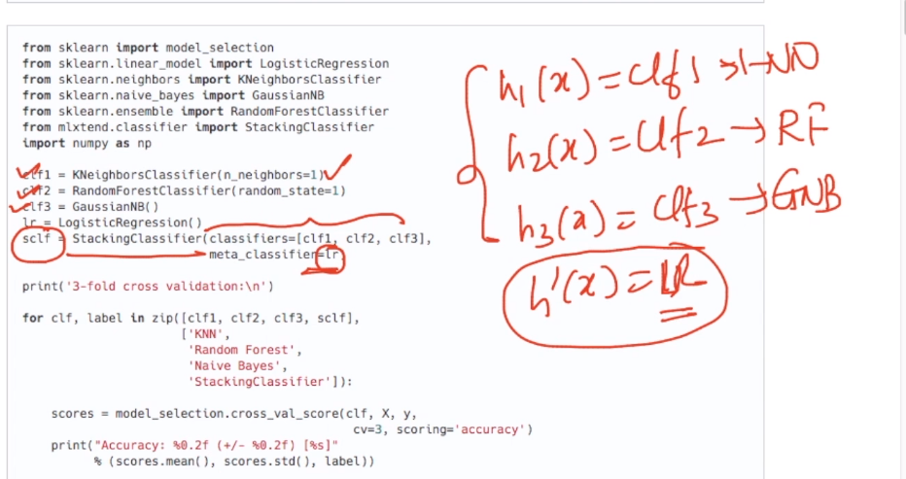

It is as simple to implement stacking from mlxtend as it is to implement any other model from sklearn.

So when we use iris data set and follow the approach than we can see that stacking model give more accuracy than any other base model.

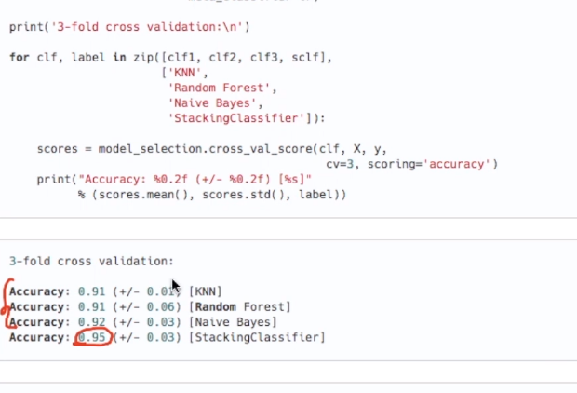

So this is all about stacking.

But there are few key points of stacking.

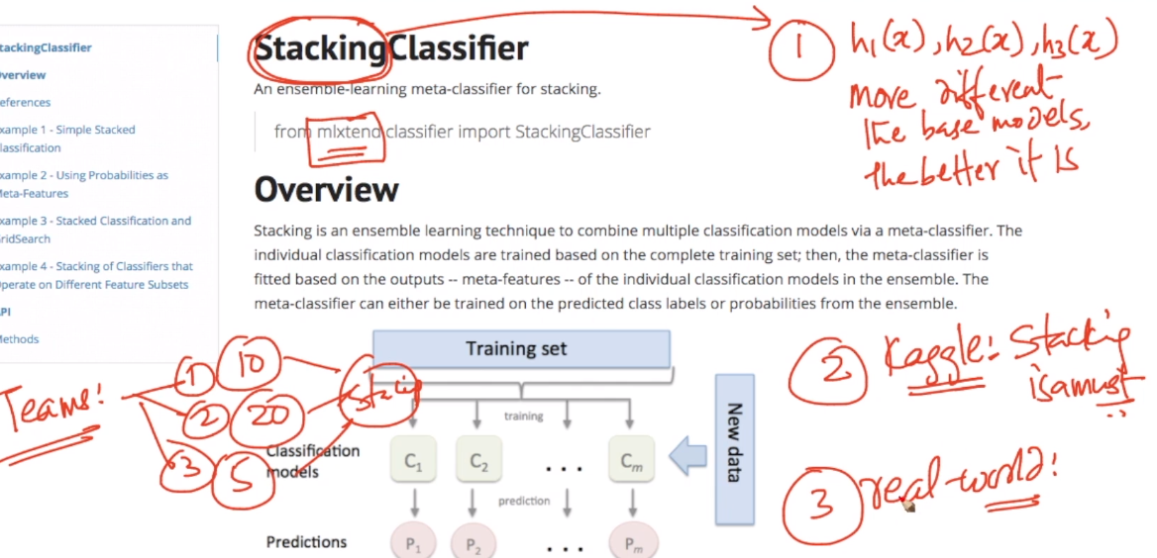

i.e. more different the model better stacking performs in most cases and in competitions like Kaggle it is must to get best results but in real world it seldom used because of its cost.

**Comments:**

